**Find the missing values. (if any, perform missing value treatment)**

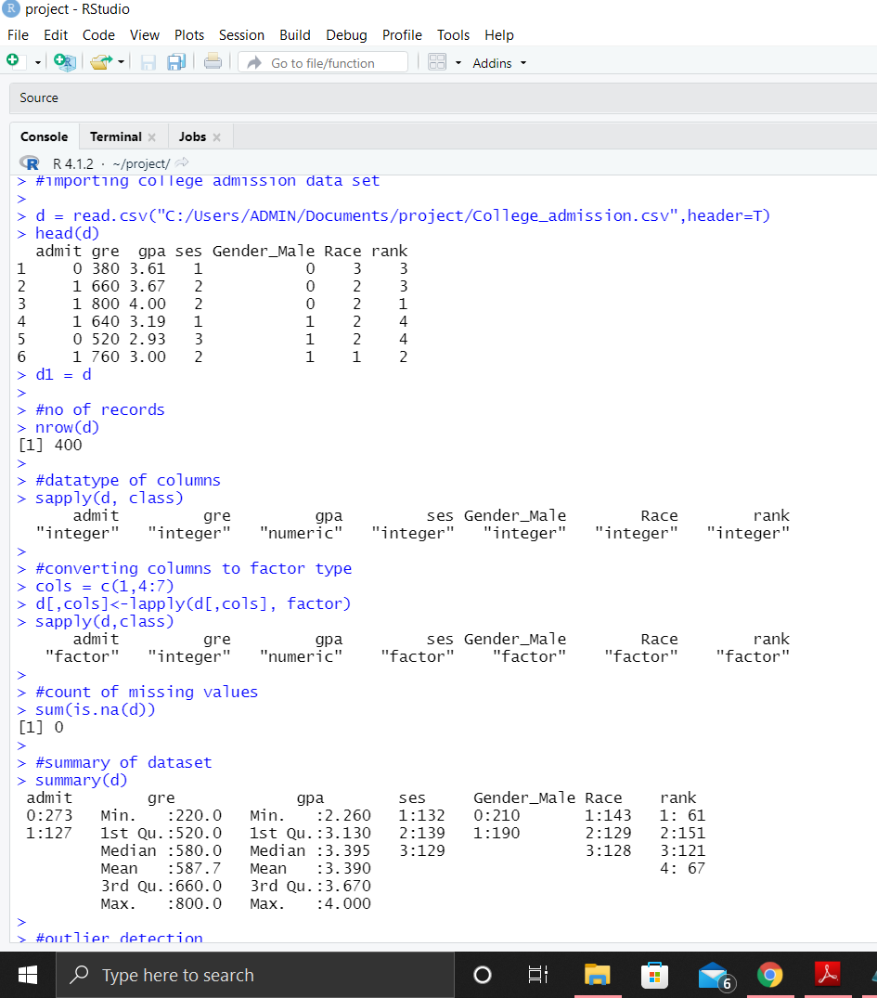

**Find outliers (if any, then perform outlier treatment)**

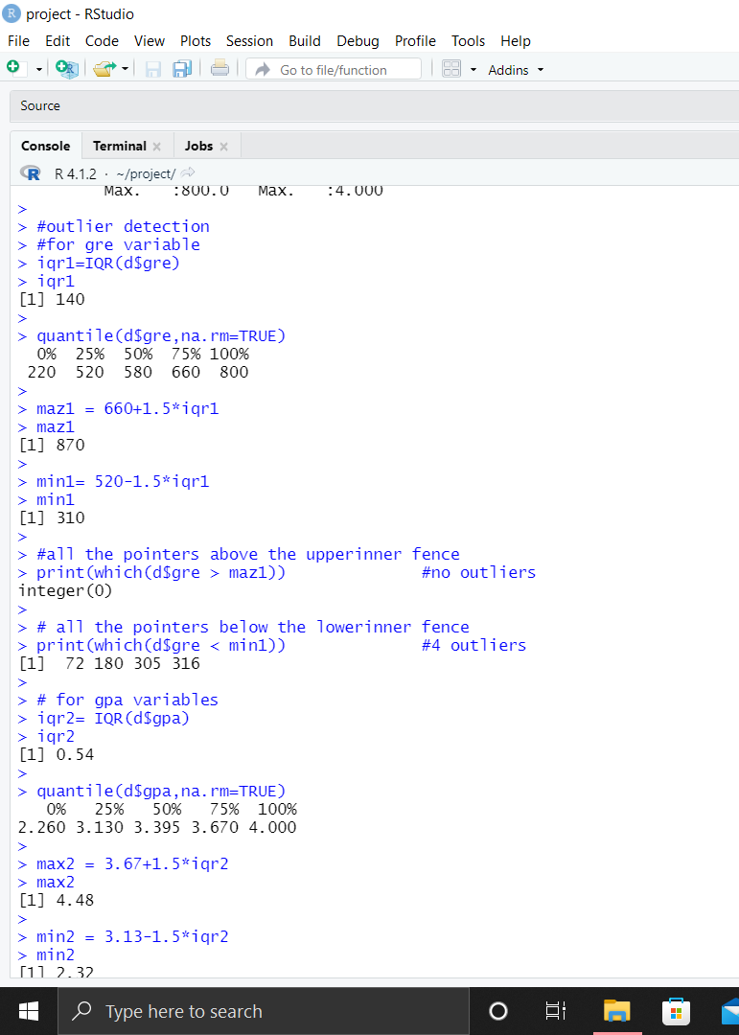

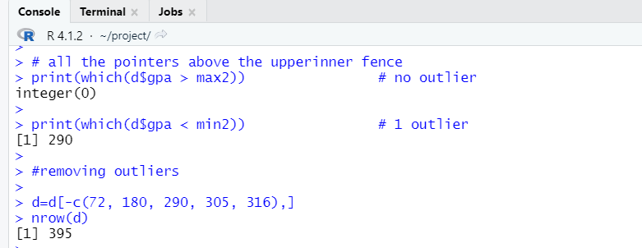

**Splitting the data into train and test**

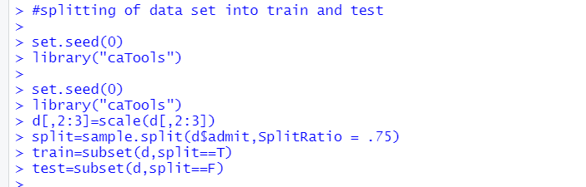

**Run logistic model to determine the factors that influence the admission process of a student (Drop insignificant variables)**

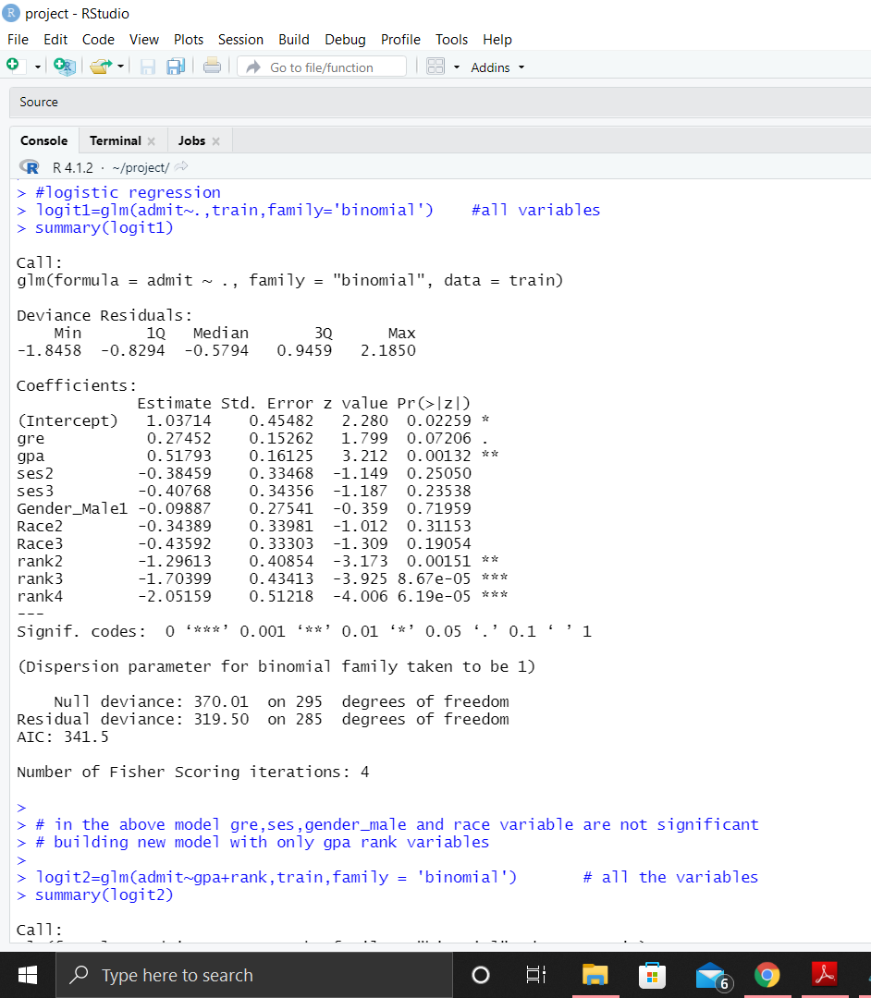

**Second logistic model by removing insignificant variables**

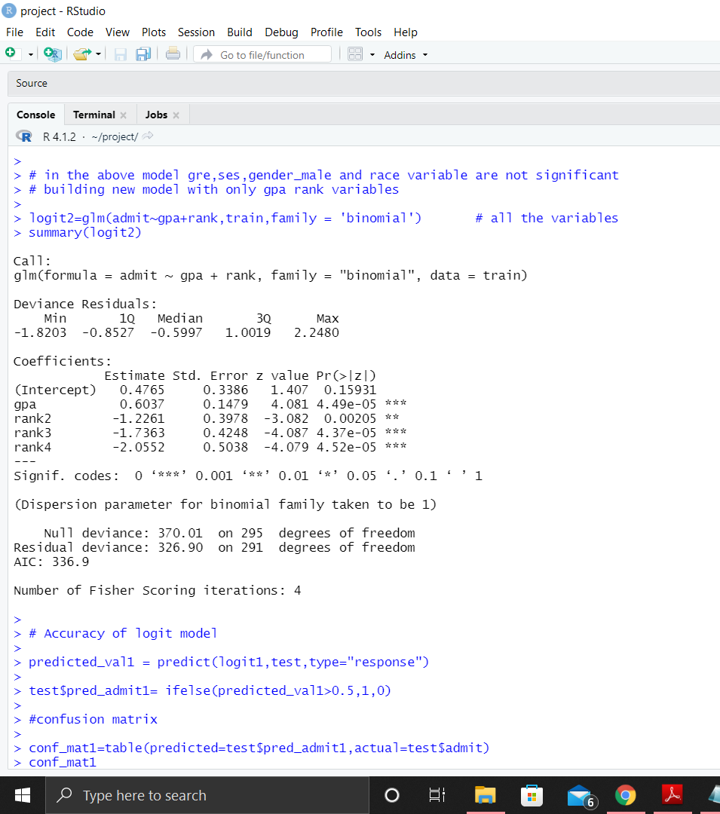

**Here residual deviation increases so we will use first model**

**Accuracy of Logistic model**

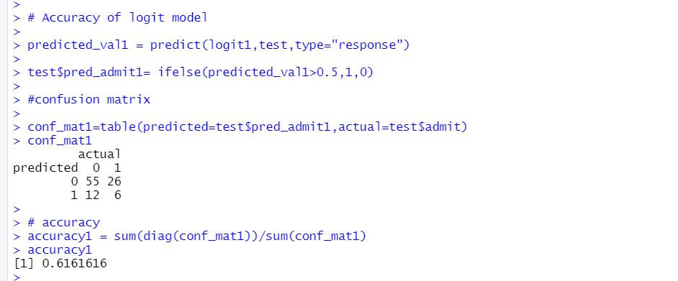

**Try other modelling techniques like decision tree and SVM and select a champion model**

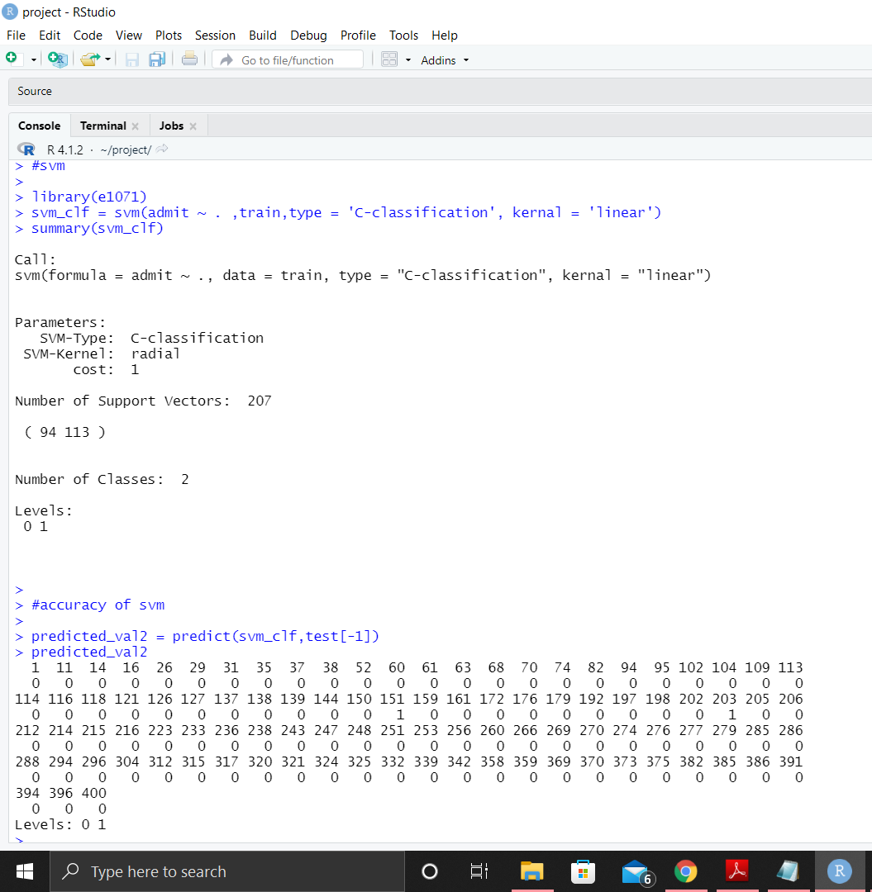

**Accuracy of SVM Model**

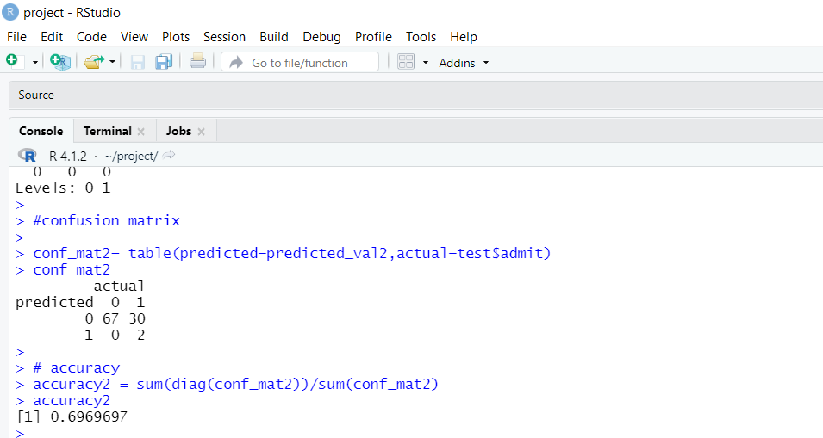

**Decision tree model**

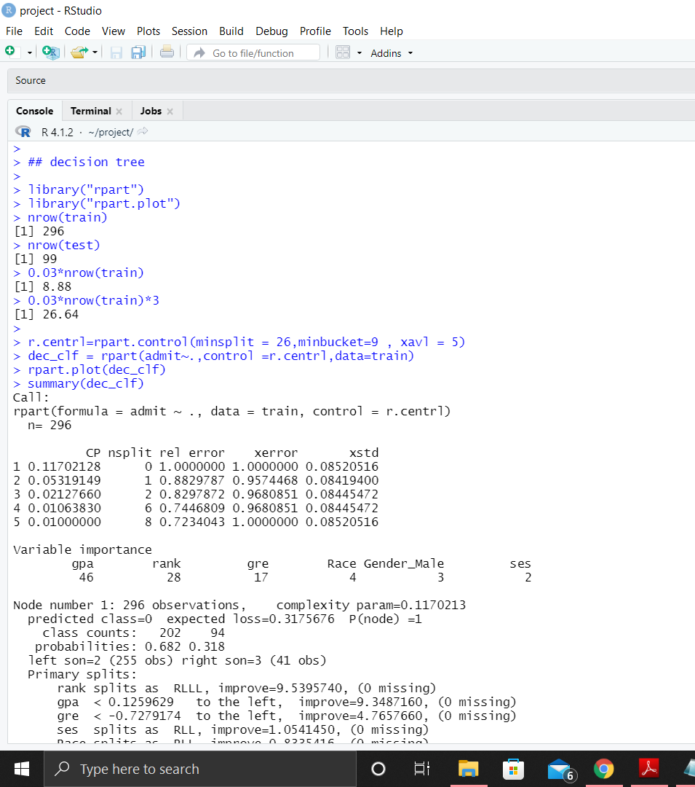

**Decision tree**

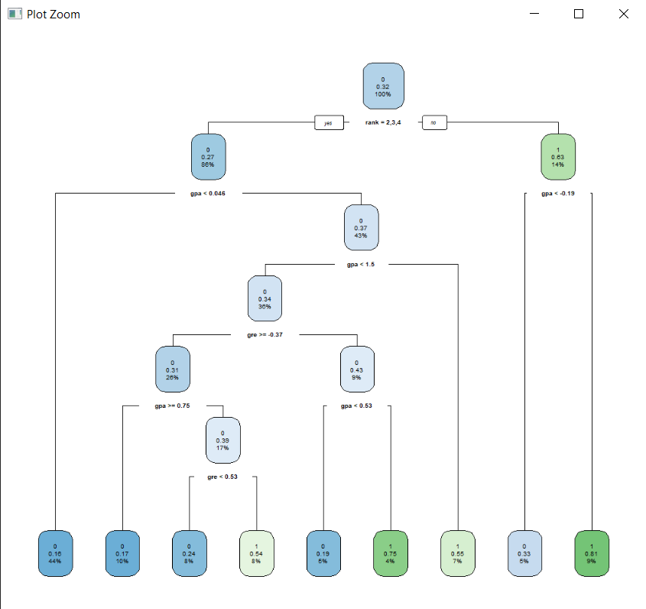

**Accuracy of Decision Tree**

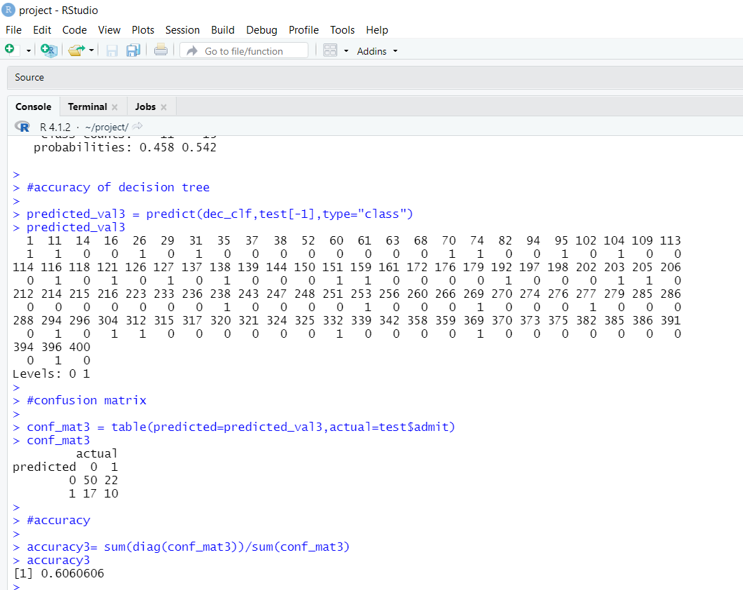

**KNN and its Accuracy**

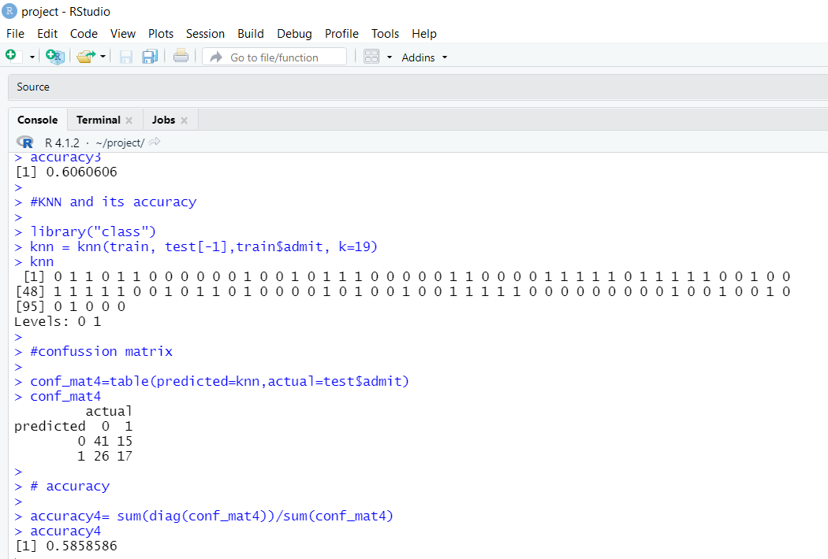

**Naïve Bayes**

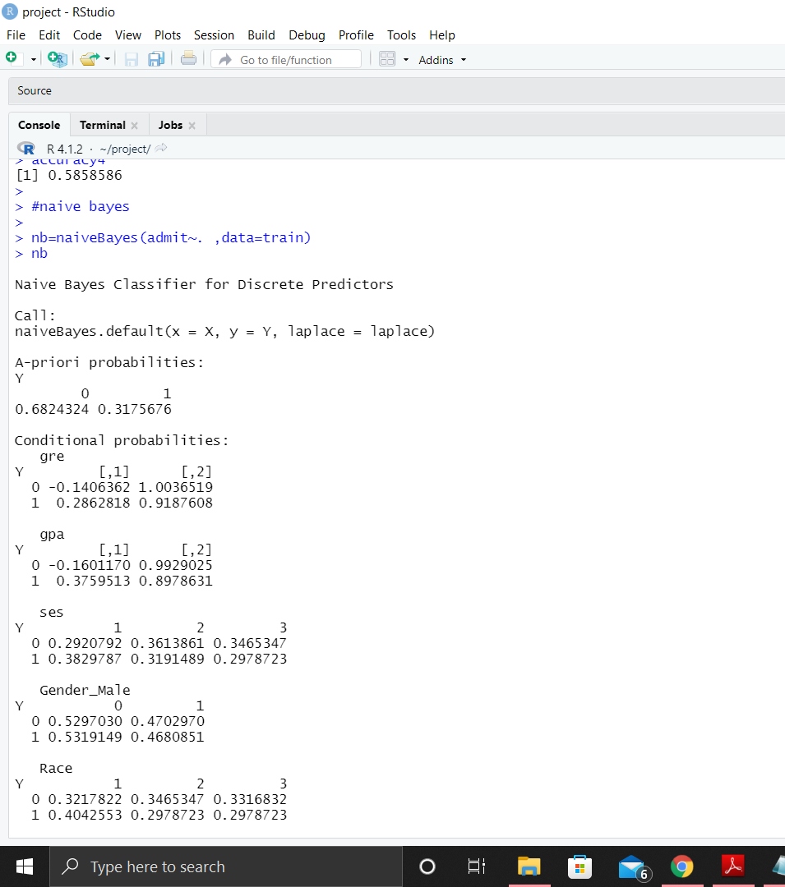

**Accuracy of Naïve Bayes**

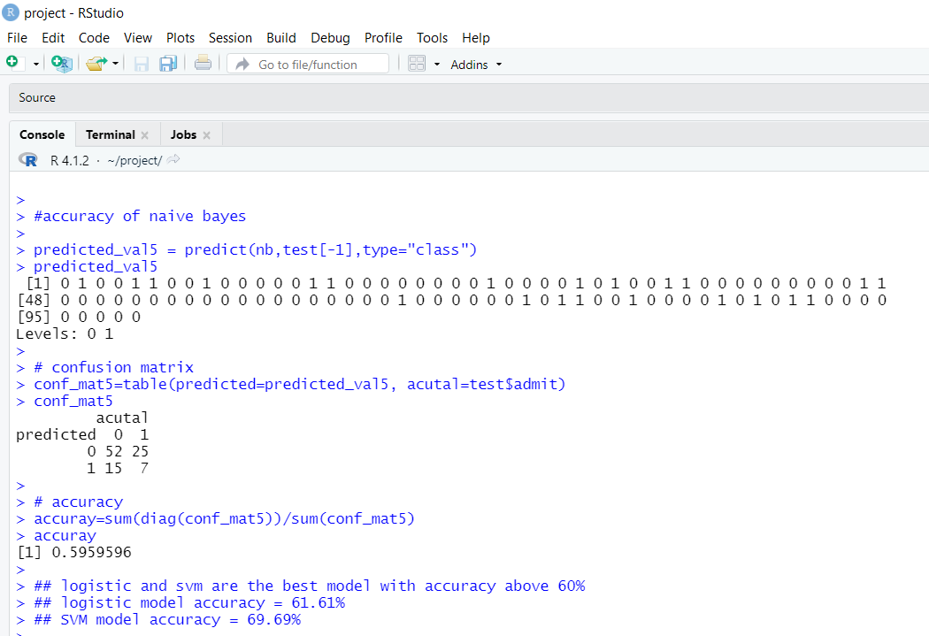

**Categorize the average of grade point into High, Medium, and Low (with admission probability percentages) and plot it on a point chart**.

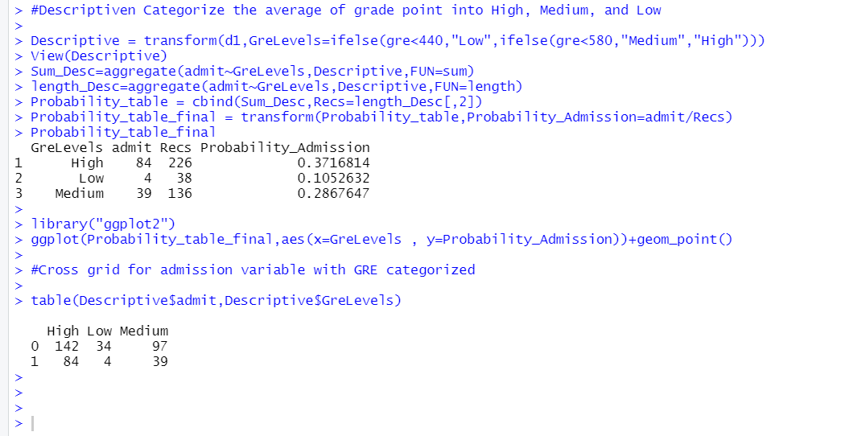

**Point Chart**

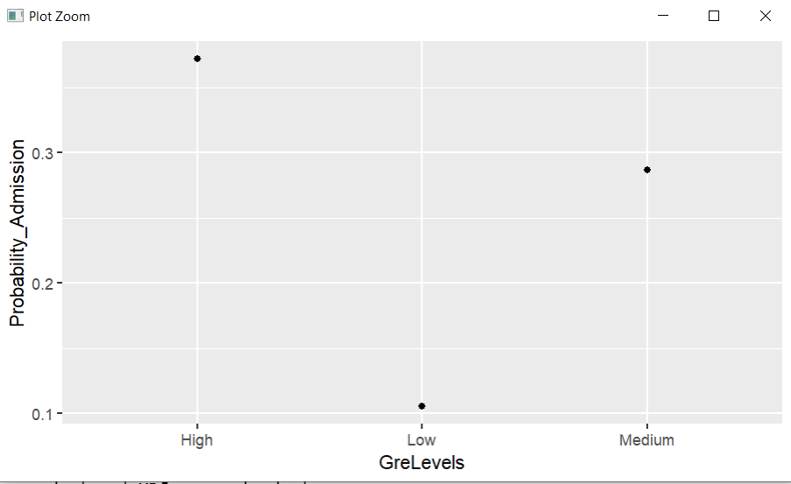

**Descriptive showing GreLevels**

